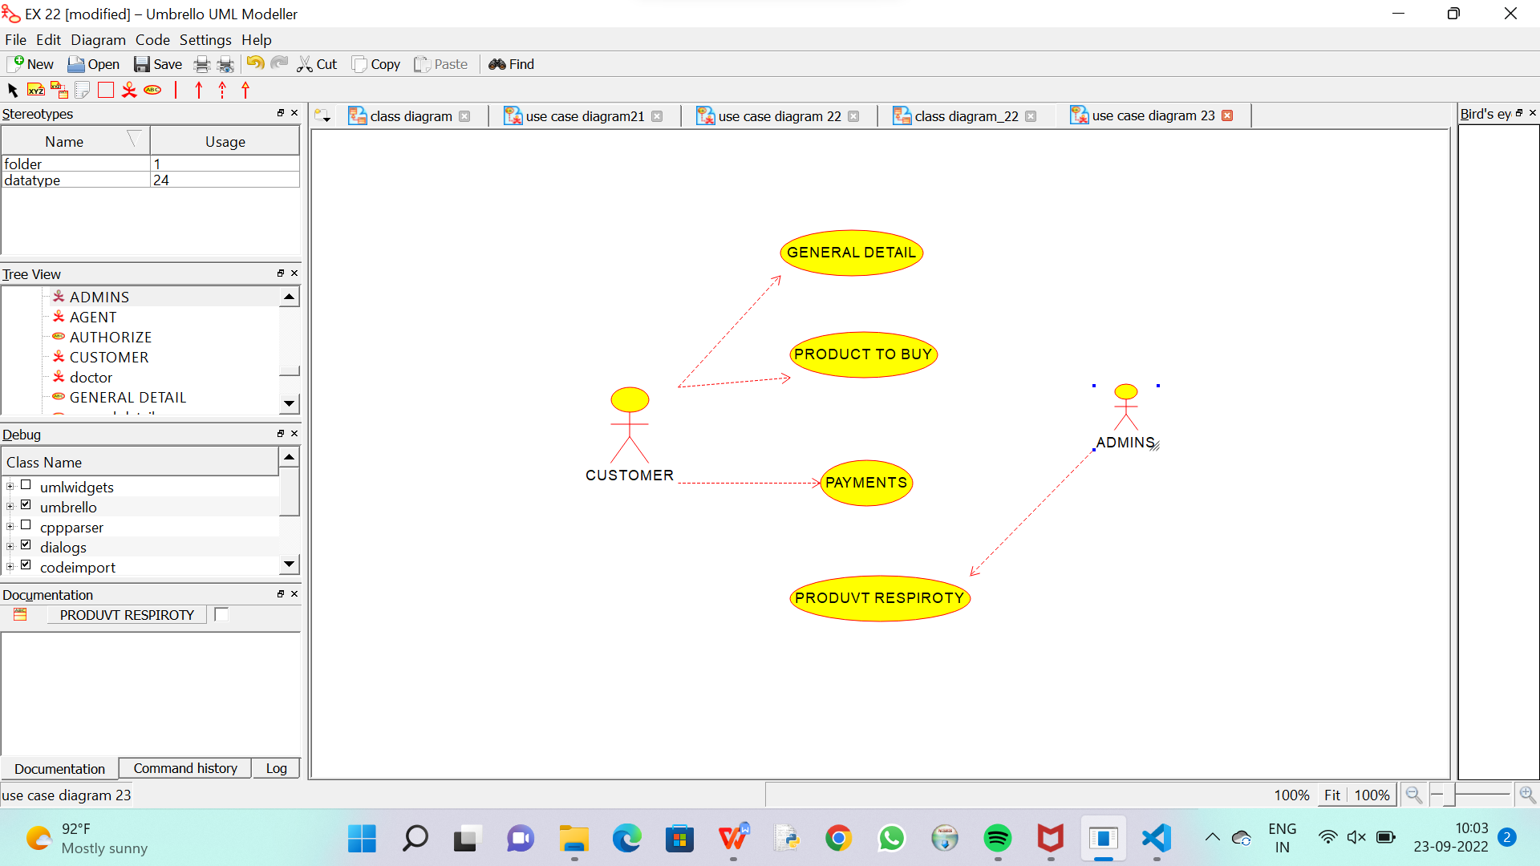

C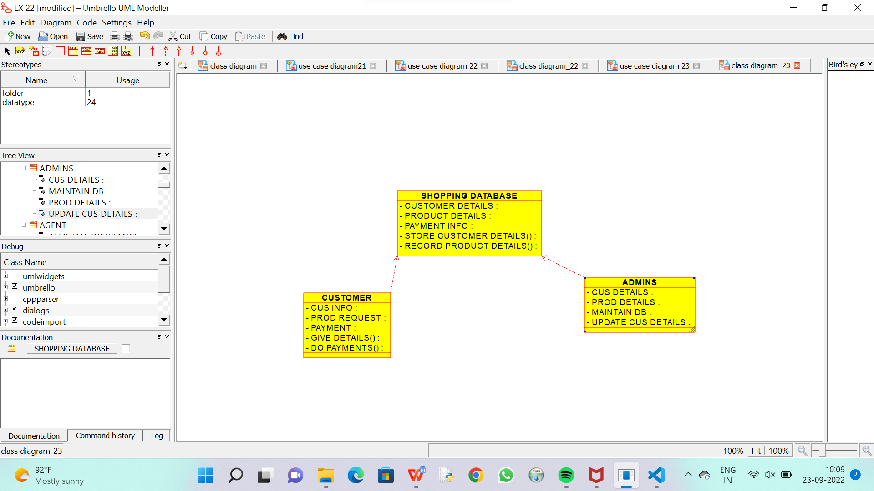

CODE FOR SHOPPING DATABASE :

/**

 * Class SHOPPING_DATABASE

 */

public class SHOPPING_DATABASE {

  //

  // Fields

  //

  private void CUSTOMER_DETAILS;

  private void PRODUCT_DETAILS;

  private void PAYMENT_INFO;

  private void STORE_CUSTOMER_DETAILS_;

  private void RECORD_PRODUCT_DETAILS_;

  //

  // Constructors

  //

  public SHOPPING_DATABASE () { };

  //

  // Methods

  //

  //

  // Accessor methods

  //

  /**

   * Set the value of CUSTOMER_DETAILS

   * @param newVar the new value of CUSTOMER_DETAILS

   */

  private void setCUSTOMER_DETAILS (void newVar) {

    CUSTOMER_DETAILS = newVar;

  }

  /**

   * Get the value of CUSTOMER_DETAILS

   * @return the value of CUSTOMER_DETAILS

   */

  private void getCUSTOMER_DETAILS () {

    return CUSTOMER_DETAILS;

  }

  /**

   * Set the value of PRODUCT_DETAILS

   * @param newVar the new value of PRODUCT_DETAILS

   */

  private void setPRODUCT_DETAILS (void newVar) {

    PRODUCT_DETAILS = newVar;

  }

  /**

   * Get the value of PRODUCT_DETAILS

   * @return the value of PRODUCT_DETAILS

   */

  private void getPRODUCT_DETAILS () {

    return PRODUCT_DETAILS;

  }

  /**

   * Set the value of PAYMENT_INFO

   * @param newVar the new value of PAYMENT_INFO

   */

  private void setPAYMENT_INFO (void newVar) {

    PAYMENT_INFO = newVar;

  }

  /**

   * Get the value of PAYMENT_INFO

   * @return the value of PAYMENT_INFO

   */

  private void getPAYMENT_INFO () {

    return PAYMENT_INFO;

  }

  /**

   * Set the value of STORE_CUSTOMER_DETAILS_

   * @param newVar the new value of STORE_CUSTOMER_DETAILS_

   */

  private void setSTORE_CUSTOMER_DETAILS_ (void newVar) {

    STORE_CUSTOMER_DETAILS_ = newVar;

  }

  /**

   * Get the value of STORE_CUSTOMER_DETAILS_

   * @return the value of STORE_CUSTOMER_DETAILS_

   */

  private void getSTORE_CUSTOMER_DETAILS_ () {

    return STORE_CUSTOMER_DETAILS_;

  }

  /**

   * Set the value of RECORD_PRODUCT_DETAILS_

   * @param newVar the new value of RECORD_PRODUCT_DETAILS_

   */

  private void setRECORD_PRODUCT_DETAILS_ (void newVar) {

    RECORD_PRODUCT_DETAILS_ = newVar;

  }

  /**

   * Get the value of RECORD_PRODUCT_DETAILS_

   * @return the value of RECORD_PRODUCT_DETAILS_

   */

  private void getRECORD_PRODUCT_DETAILS_ () {

    return RECORD_PRODUCT_DETAILS_;

  }

  //

  // Other methods

  //

}

CODE FOR CUSTOMER :

/**

 * Class CUSTOMER

 */

public class CUSTOMER {

  //

  // Fields

  //

  private void CUS_INFO;

  private void PROD_REQUEST;

  private void PAYMENT;

  private void GIVE_DETAILS_;

  private void DO_PAYMENTS_;

  //

  // Constructors

  //

  public CUSTOMER () { };

  //

  // Methods

  //

  //

  // Accessor methods

  //

  /**

   * Set the value of CUS_INFO

   * @param newVar the new value of CUS_INFO

   */

  private void setCUS_INFO (void newVar) {

    CUS_INFO = newVar;

  }

  /**

   * Get the value of CUS_INFO

   * @return the value of CUS_INFO

   */

  private void getCUS_INFO () {

    return CUS_INFO;

  }

  /**

   * Set the value of PROD_REQUEST

   * @param newVar the new value of PROD_REQUEST

   */

  private void setPROD_REQUEST (void newVar) {

    PROD_REQUEST = newVar;

  }

  /**

   * Get the value of PROD_REQUEST

   * @return the value of PROD_REQUEST

   */

  private void getPROD_REQUEST () {

    return PROD_REQUEST;

  }

  /**

   * Set the value of PAYMENT

   * @param newVar the new value of PAYMENT

   */

  private void setPAYMENT (void newVar) {

    PAYMENT = newVar;

  }

  /**

   * Get the value of PAYMENT

   * @return the value of PAYMENT

   */

  private void getPAYMENT () {

    return PAYMENT;

  }

  /**

   * Set the value of GIVE_DETAILS_

   * @param newVar the new value of GIVE_DETAILS_

   */

  private void setGIVE_DETAILS_ (void newVar) {

    GIVE_DETAILS_ = newVar;

  }

  /**

   * Get the value of GIVE_DETAILS_

   * @return the value of GIVE_DETAILS_

   */

  private void getGIVE_DETAILS_ () {

    return GIVE_DETAILS_;

  }

  /**

   * Set the value of DO_PAYMENTS_

   * @param newVar the new value of DO_PAYMENTS_

   */

  private void setDO_PAYMENTS_ (void newVar) {

    DO_PAYMENTS_ = newVar;

  }

  /**

   * Get the value of DO_PAYMENTS_

   * @return the value of DO_PAYMENTS_

   */

  private void getDO_PAYMENTS_ () {

    return DO_PAYMENTS_;

  }

  //

  // Other methods

  //

}

/**

 * Class ADMINS

 */

public class ADMINS {

  //

  // Fields

  //

  private void CUS_DETAILS;

  private void PROD_DETAILS;

  private void MAINTAIN_DB;

  private void UPDATE_CUS_DETAILS;

  //

  // Constructors

  //

  public ADMINS () { };

  //

  // Methods

  //

  //

  // Accessor methods

  //

  /**

   * Set the value of CUS_DETAILS

   * @param newVar the new value of CUS_DETAILS

   */

  private void setCUS_DETAILS (void newVar) {

    CUS_DETAILS = newVar;

  }

  /**

   * Get the value of CUS_DETAILS

   * @return the value of CUS_DETAILS

   */

  private void getCUS_DETAILS () {

    return CUS_DETAILS;

  }

  /**

   * Set the value of PROD_DETAILS

   * @param newVar the new value of PROD_DETAILS

   */

  private void setPROD_DETAILS (void newVar) {

    PROD_DETAILS = newVar;

  }

  /**

   * Get the value of PROD_DETAILS

   * @return the value of PROD_DETAILS

   */

  private void getPROD_DETAILS () {

    return PROD_DETAILS;

  }

  /**

   * Set the value of MAINTAIN_DB

   * @param newVar the new value of MAINTAIN_DB

   */

  private void setMAINTAIN_DB (void newVar) {

    MAINTAIN_DB = newVar;

  }

  /**

   * Get the value of MAINTAIN_DB

   * @return the value of MAINTAIN_DB

   */

  private void getMAINTAIN_DB () {

    return MAINTAIN_DB;

  }

  /**

   * Set the value of UPDATE_CUS_DETAILS

   * @param newVar the new value of UPDATE_CUS_DETAILS

   */

  private void setUPDATE_CUS_DETAILS (void newVar) {

    UPDATE_CUS_DETAILS = newVar;

  }

  /**

   * Get the value of UPDATE_CUS_DETAILS

   * @return the value of UPDATE_CUS_DETAILS

   */

  private void getUPDATE_CUS_DETAILS () {

    return UPDATE_CUS_DETAILS;

  }

  //

  // Other methods

  //

}